Experiment - 2

Aim:
To study and implement Hosted Virtualization using VirtualBox & KVM.

Theory:
Virtualization: Concepts, Types, Structures, and Mechanisms-
Using virtualization, hardware resources can be used more effectively by running different operating systems on a single physical machine. Virtualized instances of computer resources, including servers, storage, and networks, are created throughout this procedure. It is possible to manage and deploy programs more efficiently thanks to virtualization's flexibility, scalability, and resource isolation.

Types of Virtualization-
1. Hardware Virtualization:
It utilizes a hypervisor to create and manage virtual machines (VMs) on a host system. Each VM operates as an independent system, running its own operating system.

2. Software Virtualization:
It uses application-level virtualization to run multiple instances of an application on a single host. Isolation is achieved at the application level rather than the entire operating system.

3. Network Virtualization:
It abstracts and combines network resources to create a virtual network. Enhances scalability, security, and flexibility in network management.

4. Storage Virtualization:
Pooling of physical storage resources to create a virtual storage infrastructure and simplifies storage management and improves efficiency.

Structures of Virtualization-
1. Full Virtualization:
Hypervisor simulates the entire hardware environment, allowing unmodified guest operating systems to run.
Example: VMware, VirtualBox.
2. Para-Virtualization:
Guest operating systems are modified to be aware of the virtualization layer.
It enhances performance by reducing the overhead of virtualization.
Example: Xen.

3. Container-Based Virtualization:
Virtualization at the OS level, enabling the creation of lightweight, portable containers.
It is also efficient resource utilization and quick deployment.
Example: Docker, Kubernetes.

Mechanisms of Virtualization-
1. Hypervisor (Virtual Machine Monitor - VMM):
Manages and allocates physical resources to virtual machines.
Types: Type-1 (bare-metal) and Type-2 (hosted).
Examples: KVM, VirtualBox, Hyper-V.

2. Emulation:
Mimics the behavior of hardware to run software designed for a different architecture.
Slower compared to native execution but allows cross-platform compatibility.

Comparison Parameters:
1. Performance: KVM often offers better performance due to its kernel-level integration.
2. Ease of Use: VirtualBox is more user-friendly with a GUI, while KVM may require command-line expertise.
3. Resource Utilization: KVM is often more efficient, utilizing fewer resources for similar workloads.
4. Scalability: KVM is better suited for large-scale deployments and server environments.
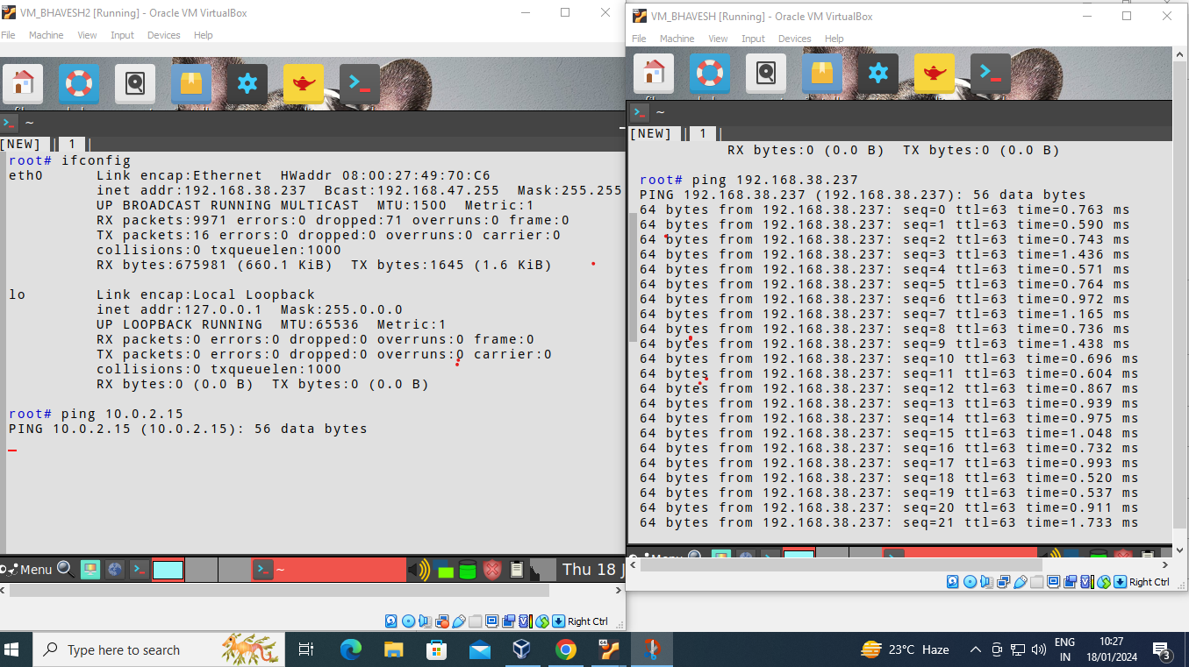

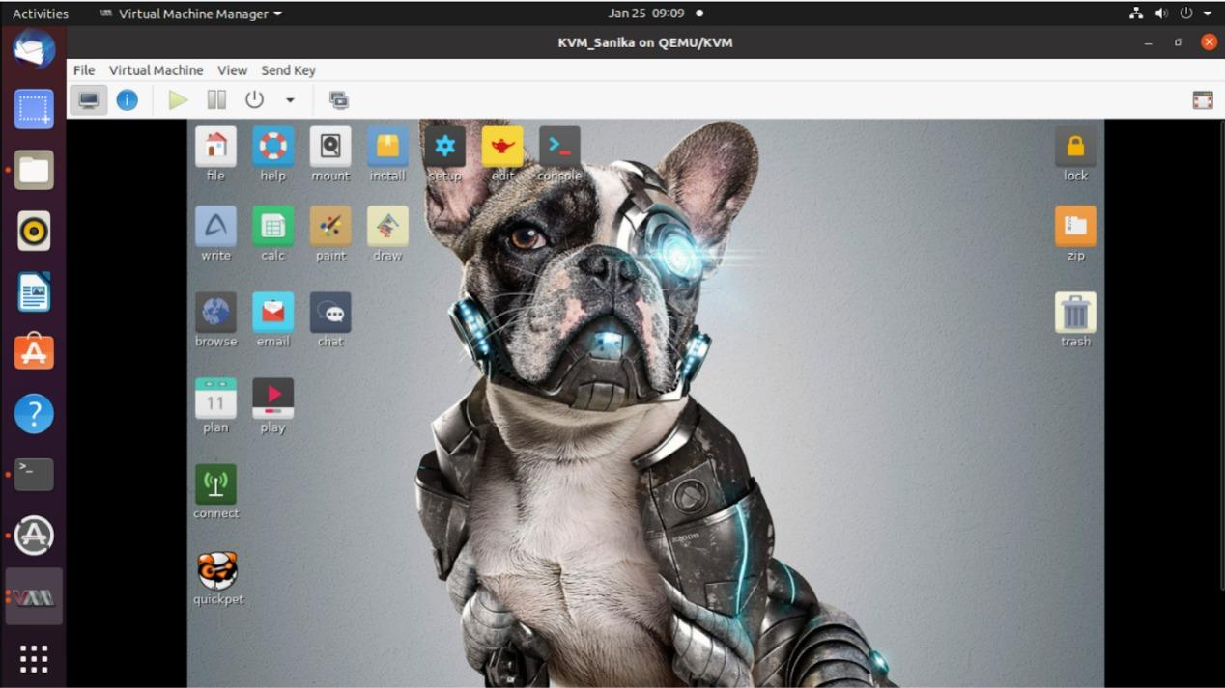
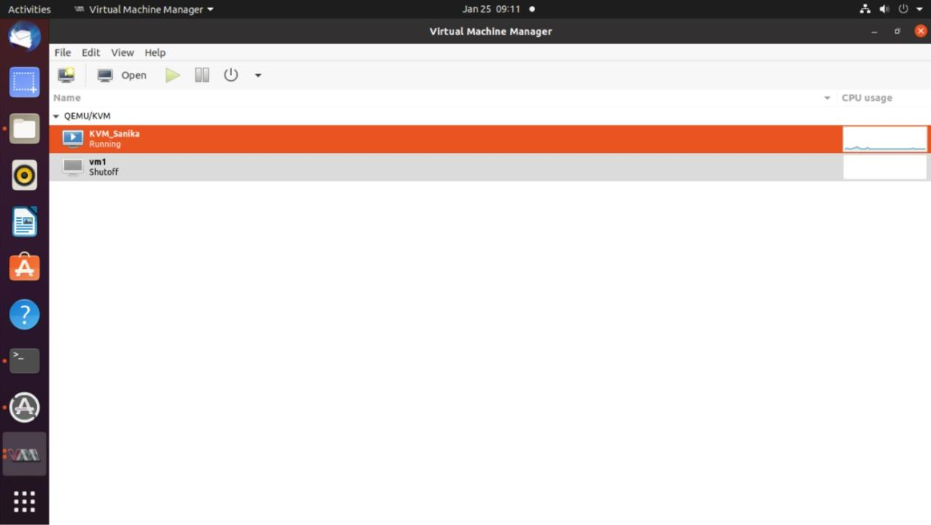

Conclusion:-
VirtualBox and KVM provide useful virtualization solutions with different features. Because it's an easy-to-use Type-2 hypervisor, VirtualBox is perfect for testing and desktop environments. KVM, on the other hand, performs best in server contexts with higher performance and resource efficiency because it is a Type-1 hypervisor built into the Linux kernel. KVM is useful for its benefits in performance and scalability, while VirtualBox is better suited for simplicity and convenience of use. The virtualization platform that an organization chooses must take into account many criteria such as technical competence, infrastructure size, and workload. Virtualization technology's adaptability enables companies to maximize their IT investments, improve operational effectiveness, and adjust to changing computing needs.

